**Project: My Resume Portfolio**

**Dated: Oct 11,2020**

**Version: 0.1**

**Introduction:** This web application reflects my resume by highlighting about me, my Education, Work History, Personal Projects, Achievements and etc.

**Technologies:** The major technologies used in creating this web application are MongoDB, ExpressJS, ReactJS, Node.js, Nodemon.

**Project Structure:** For simplicity, both front end and back end have been kept together. Public and src folders contains the front end while folder named backend contains all the folders and files related to backend i.e models, routes to backend etc.

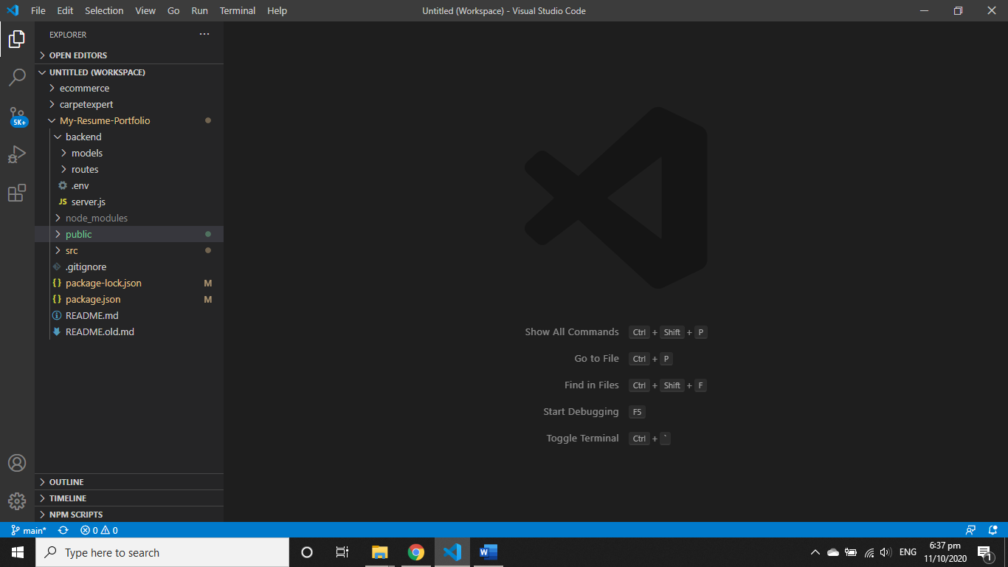

**Figure Project Structure**

**Front End:**

**Public Folder:** Contains the essential project resources like css, images, styles, js scripts.

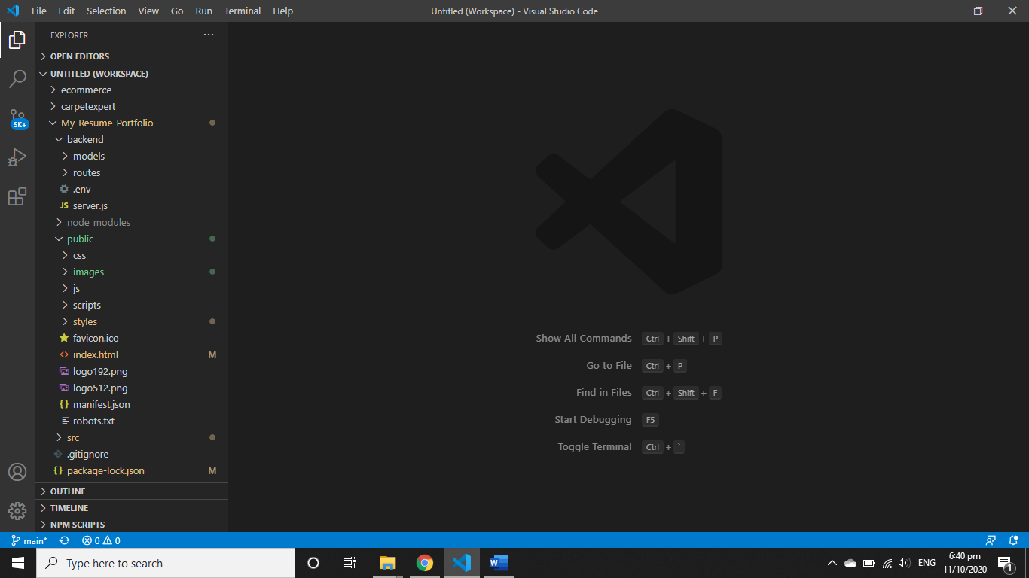

**src:** This folder contains the core files, react components and pages of our web application. The react components of this project have been kept inside components folder and been called in App.js.

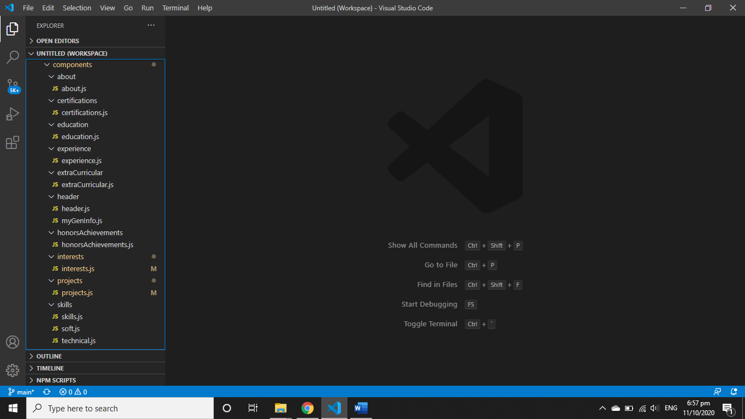

As shown in above figure, each section of resume has been kept inside separate folders containing separates files for sub sections too.

**Backend:** The projects’ titles and descriptions have been kept in MongoDB. So the schema has been defined in projects.js inside models folder. The routing to handle client requests has been defined in projects.js inside routes folder.

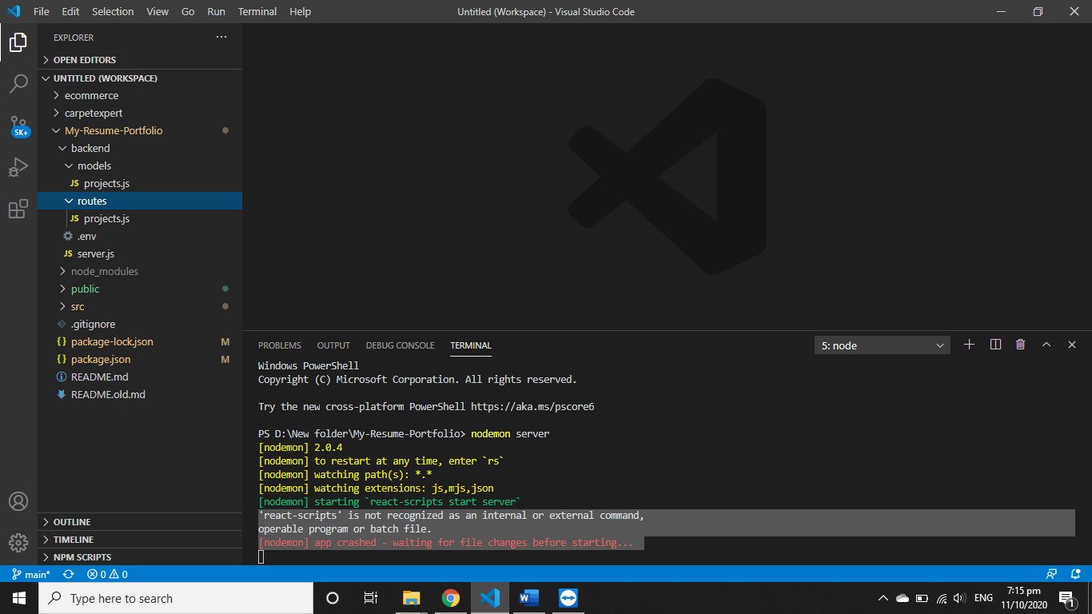

**Backend**